STATIC STRUCTURAL AND FATIGUE ANALYSIS OF SUSPENSION COMPONENTS

By

CHAITANYA GAJBHIYE
REGISTRATION NO. 20236048
B.TECH (7th SEMESTER)
MECHANICAL ENGINEERING

Personal Project Report


Motilal Nehru National Institute of Technology Allahabad
Prayagraj, UP, India, 211004

September 2026

DECLARATION
I Chaitanya Gajbhiye hereby declare that this project report is wholly my own work and has not been submitted anywhere else for academic credit, either by myself or another person.

I understand what plagiarism implies and declare that this report embodies my own ideas, words, phrases, arguments, graphics, figures, results and organization except where reference is explicitly made to another work.

I understand further that any unethical academic behaviour, which includes plagiarism, is seen in a serious light by MNNIT Allahabad and is punishable by disciplinary action as stipulated by the institute’s rules and regulations.


Date: 01/09/2026 Name: Chaitanya Gajbhiye
Reg. No: 20236048
Signature:

ACKNOWLEDGEMENT
Although this project was conceived and completed independently, it could not have reached completion without the supportive academic ecosystem at Motilal Nehru National Institute of Technology Allahabad.
I would like to acknowledge the Department of Mechanical Engineering for providing access to the design and simulation software essential for this work. I am also thankful to my professors, colleagues, and family for their encouragement and moral support during the execution of this project and the preparation of this report.

Date: 01/09/2026 Name: Chaitanya Gajbhiye
Reg. No: 20236048
Signature:

ABSTRACT
This report presents the finite element analysis (FEA) and design evaluation of a vehicle suspension system. The suspension system is a critical subassembly responsible for absorbing road irregularities, ensuring handling stability, and transmitting loads safely. The motivation behind this study is to move beyond expensive trial-and-error physical prototyping by leveraging virtual simulation during the design phase to predict failure zones and ensure structural reliability under extreme vehicle operating conditions.

The methodology involved modelling the complete Double-wishbone Suspension assembly and generating its Bill of Materials (BOM) in SolidWorks. Key components – specifically the Upper and Lower A-Arm and Shock Absorber, were isolated, assigned real-world dimensions and engineering materials (such as Aluminium Alloy 6061-T6 and Alloy Steels), and analysed in ANSYS Workbench. For the A-Arm, a Static Structural analysis under a 10,000 N peak load and Modal analysis were conducted. For the Shock Absorber, a Static Structural analysis under a 3,000 N remote compression force and a Fatigue analysis were performed. Results demonstrated that the A-Arm experienced a maximum von Mises stress of 45.386 MPa and a total deformation of 0.0228 mm, with a minimum static factor of safety of 5.711. The Shock Absorber assembly showed a peak stress of 67.155 MPa and a maximum deformation of 7.05 mm, maintaining a safe static factor of safety of 3.85. Furthermore, durability evaluations confirmed robust fatigue lives exceeding ${10}^{7}$ to ${10}^{8}$ cycles for both components.

In conclusion, the finite element evaluations successfully validated the mechanical performance and safety margins of the suspension system under severe bump and cyclic loading scenarios. The primary advantage of this work lies in its capacity to optimize component designs and prevent structural failure early in development. Future scope includes integrating multi-body dynamics, terrain interaction models, and weight-optimization techniques to further enhance suspension efficiency.

TABLE OF CONTENTS
DECLARATION 1
ACKNOWLEDGEMENT 2
ABSTRACT 3
TABLE OF CONTENTS 4
LIST OF FIGURES 5
LIST OF TABLES 6
CHAPTER 1: INTRODUCTION 7
1.1 General Remarks 7
1.2 Introduction 7
1.3 Applications 7
1.4 Motivation 8
1.5 Scope of Work 8
CHAPTER 2: LITERATURE REVIEW 10
2.1 Introduction 10
2.2 Suspension Assembly Components 10
2.3 Structural FEA of Suspension Systems 11
2.4 Fatigue FEA Analysis of Suspension Systems 12
2.5 Material Mechanical Properties 12
CHAPTER 3: METHODOLOGY OF FEA MODELING 13
3.1 3D CAD Geometry and Assembly 13
3.2 Material Selection and Assignment 13
3.3 Finite Element Discretization (Meshing) 14
3.4 Fixed Support and Loading Conditions 16
CHAPTER 4: RESULTS AND DISCUSSION 18
CHAPTER 5: CONCLUSION 27
5.1. Conclusions 27
5.2. Future work 27
REFERENCES 29

LIST OF FIGURES
Figure 1 – Automobile Suspension System Assembly 10
Figure 2 – Suspension Lower A-Arm (Control Arm) Model 11
Figure 3 - Shock Absorber Assembly Model 11
Figure 4 - Shock Absorber Assembly 11
Figure 5 - Material Selection for Lower A-Arm (Control Arm) 14
Figure 6 - Material Selection for Shock Absorber 14
Figure 7 - Meshing Details along with Mesh Quality Metrics for Shock Absorber 15
Figure 8 - Meshing Details along with Mesh Quality Metrics for Lower A-Arm 15
Figure 9 - Forces and Supports for Shock Absorber 16
Figure 10 - Forces and Supports for Lower A-Arm 17
Figure 11 - Equivalent Stress on Shock Absorber 18
Figure 12 - Equivalent Elastic Strain on Shock Absorber 18
Figure 13 - Total Deformation of Shock Absorber 19
Figure 14 - Factor of Safety of Shock Absorber 19
Figure 15 – Fatigue Damage to Shock Absorber 19
Figure 16 - Fatigue Life of Shock Absorber 20
Figure 17 - Fatigue Safety Factor of Shock Absorber 20
Figure 18 - Equivalent Stress on Lower A-Arm 21
Figure 19 – Total Deformation on Lower A-Arm 21
Figure 20 – Factor of Safety of Lower A-Arm 22
Figure 21 - Fatigue Life of Lower A-Arm 22
Figure 22 – Damage to Lower A-Arm 22
Figure 23 -Fatigue Safety Factor of Lower A-Arm 23
Figure 24 - Modal Shape 1 (Total Deformation 1) 23
Figure 25 - Modal Shape 2 (Total Deformation 2) 24
Figure 26 - Modal Shape 3 (Total Deformation 3) 24
Figure 27 - Modal Shape 4 (Total Deformation 4) 25
Figure 28 - Modal Shape 5 (Total Deformation 5) 25
Figure 29 - Modal Shape 6 (Total Deformation 6) 25
Figure 30 - Modal Shape 7 (Total Deformation 7) 26

LIST OF TABLES

Table 2.1: Engineering Material Data Sources (Ansys). 12

CHAPTER 1: INTRODUCTION
_________________________________________________________________________

1.1 General Remarks
Vehicle suspension systems have been utilized for decades and have continuously evolved to become far superior to conventional fixed-axle or basic dampening setups in terms of handling and ride safety. In modern vehicle dynamics, numerous structural materials with high specific strength, exceptional fatigue resistance, and low mass are required. As lightweighting demands increase across automotive and motorsports industries (such as Formula Student, Baja SAE, and high-performance ATVs), it is essential to implement efficient design and analysis workflows that not only simplify component geometry and manufacturing but also ensure maximum structural safety under aggressive load scenarios. Leveraging virtual simulation provides a cost-effective, highly efficient mechanism to evaluate complex multi-axial forces before physical prototyping.

1.2 Introduction
The purpose of this study was to develop and formulate a comprehensive finite element analysis (FEA) model for a vehicle suspension system comprising a complete Double-Wishbone Suspension System assembly, which includes mainly the Upper and Lower A-Arm, and a Shock Absorber unit, which can then be used to evaluate structural integrity, stress distribution, deformation, and fatigue life under extreme operating conditions.

1.3 Applications
Since there are many factors/parameters that affect the water jet cutting process; the factors were listed as [1] FEM-based suspension analysis and multi-component mechanical modelling find broad applications across multiple engineering domains. Since there are many operating, geometric, and material parameters that affect the structural performance and durability of a vehicle suspension system, these key factors can be listed as:

- Vertical and cornering load magnitudes transmitted from road irregularities through the tire and hub assembly.

- Spring stiffness and pre-load characteristics of the shock absorber unit.
- Material properties (such as Young's modulus, Poisson's ratio, and yield strength) assigned to structural components like Aluminium Alloy 6061-T6 and structural steels.
- Boundary constraint configurations at the chassis mounting points and pin boss connections.
- Mesh density, element type (quadratic tetrahedral/hexahedral), and contact behaviour between mating sub-assemblies.

Building upon these parameters, applications span across:
- Automotive Design and Passenger Cars: Evaluating lower control arms, steering knuckles, and shock absorber mountings under maximum vertical bump and braking forces.
- Motorsports (Formula Student / Baja SAE): Optimizing lightweight components to meet strict structural rigidity requirements while minimizing unsprung mass.
- Off-Road and All-Terrain Vehicles (ATVs): Simulating extreme impact loading and high-cycle fatigue life under severe terrain conditions.

1.4 Motivation
The failure of suspension components due to structural yielding or fatigue under severe road impacts leads to catastrophic vehicle breakdown and high prototyping costs. Conventional trial-and-error physical testing is both expensive and time-consuming. Performing finite element analysis during the preliminary design stage allows for early identification of critical high-stress zones, material validation, and optimization, significantly reducing product development cycles.

1.5 Scope of Work
The scope of this term project encompasses the following steps:
- Model the complete double-wishbone front suspension assembly and generate its comprehensive Bill of Materials (BOM) in SolidWorks.
- Assign realistic engineering materials (such as Aluminium Alloy 6061-T6, ASTM A228 Music Wire, Carbon Steel 1095, and Low Alloy Steel 4140) to isolated components.
- Conduct Static Structural and Modal analyses on the lower A-Arm under a peak vertical load of 10,000 N.
- Conduct Static Structural and Fatigue analyses on the Shock Absorber under a 3,000 N remote compression force.
- Evaluate key metrics including total deformation, equivalent (von Mises) stress, static and fatigue factors of safety, and predicted service life cycles.

______________________________________________________

CHAPTER 2: LITERATURE REVIEW
_________________________________________________________________________

2.1 Introduction
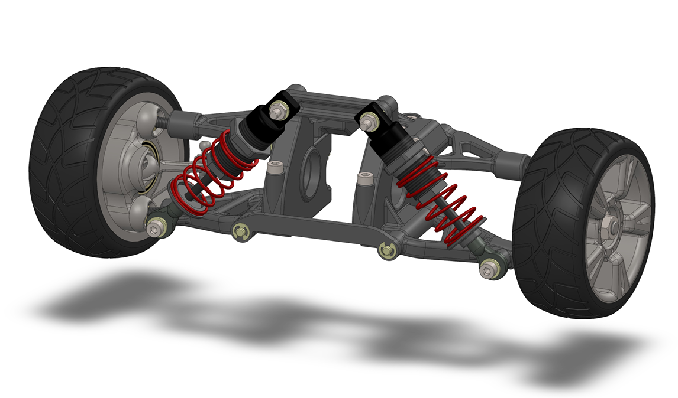
Vehicle suspension design and finite element analysis are considered core methodologies in automotive engineering, and although numerical simulations are becoming widely utilized in industry for analysing component integrity, their use is not limited to just static verification. The suspension analysis process is part of a broad engineering framework where virtual prototyping and multi-criteria optimization are implemented across the manufacturing and design sectors. The different views for this Fully Assembled Suspension System can be seen from here.

Figure 1 – Automobile Suspension System Assembly

2.2 Suspension Assembly Components
The complete front double-wishbone suspension assembly comprises numerous hardware elements, fasteners, and structural sub-assemblies as detailed in the Bill of Materials (BOM).
While every part contributes to the kinematic alignment of the system, finite element analysis (FEA) and structural validation were specifically focused on the two primary critical components that bear the maximum mechanical loads during operation:

- Suspension A-Arm (Control Arm): The principal structural link connecting the wheel hub carrier to the chassis, responsible for transmitting severe lateral, longitudinal, and vertical bump loads.
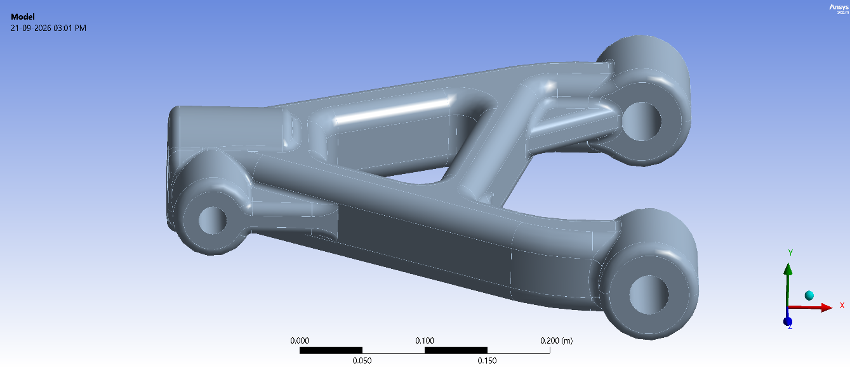
Figure 2 – Suspension Lower A-Arm (Control Arm) Model

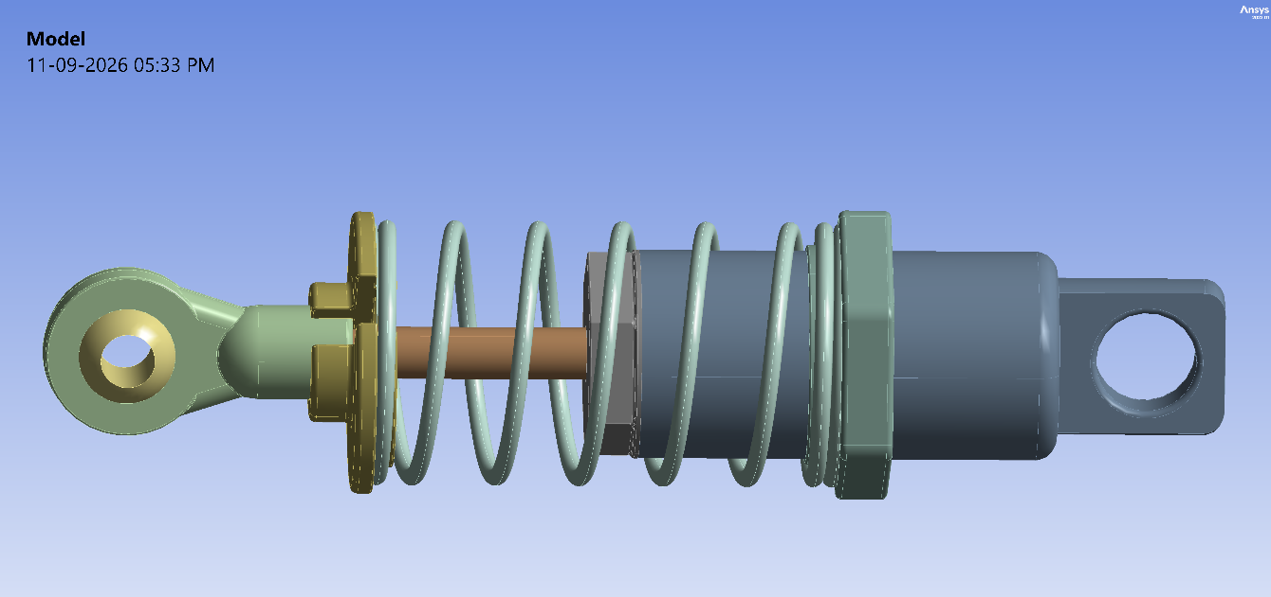
- Shock Absorber Assembly: The combined hydraulic damper and helical spring unit responsible for absorbing road impact energy and managing cyclic oscillation frequencies
Figure 3 - Shock Absorber Assembly Model
Figure 4 - Shock Absorber Assembly

2.3 Structural FEA of Suspension Systems
Classical analytical methods are inadequate for capturing complex geometries, stress concentrations, and multi-directional loading in suspension components. Consequently, finite element analysis (FEA) has become the industry standard for evaluating structural performance.
The equivalent (von Mises) stress criterion used to predict yielding in ductile suspension materials under multi-axial loading is formulated as given –
$$σ_{vm}=\sqrt{\frac{1}{2}\left[{\left(σ_{1}-σ_{2}\right)}^{2}+{\left(σ_{2}-σ_{3}\right)}^{2}+{\left(σ_{3}-σ_{1}\right)}^{2}\right]}$$

where $σ_{vm}$ is the von Mises equivalent stress, and $σ_{1},σ_{2},σ_{3}$ represent the principal normal stresses evaluated at critical nodes across the component geometry.

2.4 Fatigue FEA Analysis of Suspension Systems
Because suspension systems experience millions of load cycles over their operational lifespan, static structural evaluation alone is insufficient. Fatigue analysis utilizing S-N curves and cumulative damage models (such as the Palmgren-Miner linear damage rule) is necessary to predict service life and prevent high-cycle fatigue failures under repetitive cyclic loading.

2.5 Material Mechanical Properties

Table 2.1: Engineering Material Data Sources (Ansys).
Material | Density  (kg/m3) | Young's Modulus (GPa) | Poisson's Ratio | Yield Strength (MPa)
Aluminium Alloy 6061-T6 | 2700 | 69.036 | 0.33 | 259.2
ASTM A228 Music Wire | 7850 | 203 | 0.30 | 1590
Carbon Steel 1095 – Hardened and Tempered | 7850 | 200 | 0.29 | 525
Low Alloy Steel 4140 – Hardened and Tempered | 7850 | 205 | 0.29 | 655

CHAPTER 3: METHODOLOGY OF FEA MODELING
_________________________________________________________________________

3.1 3D CAD Geometry and Assembly
The modelling workflow began with the development of a comprehensive 3D assembly of the vehicle's front double-wishbone suspension system using SolidWorks. While the baseline layout was modelled following standard automotive architecture and instructional assembly guidelines, the two primary load-bearing components—the Suspension A-Arm and the Shock Absorber assembly—were isolated, scaled, and updated to precise real-world physical dimensions.

3.2 Material Selection and Assignment
To accurately capture physical behaviour under operating loads, specific engineering materials were assigned to each part within the isolated assemblies:

- Aluminium Alloy 6061-T6: Applied to the suspension A-Arm, housing caps, and mounting eyes due to its high strength-to-weight ratio; minimizes unsprung mass to significantly improve vehicle handling and tire-road contact.

- ASTM A228 Music Wire: Utilized for the helical suspension spring; selected for its extreme tensile strength and elasticity, enabling repeated energy absorption under heavy impacts without permanent deformation or sag.

- Low Alloy Steel 4140 - Hardened and Tempered: Applied to the main piston rod and high-stress structural shafts; chosen for high fatigue strength and toughness to withstand severe axial shocks and bending moments without yielding.

- Carbon Steel 1095 - Hardened and Tempered: Utilized for internal locking rings and collars; chosen for high surface hardness and wear resistance to prevent joint loosening and frictional degradation under continuous vibrations.
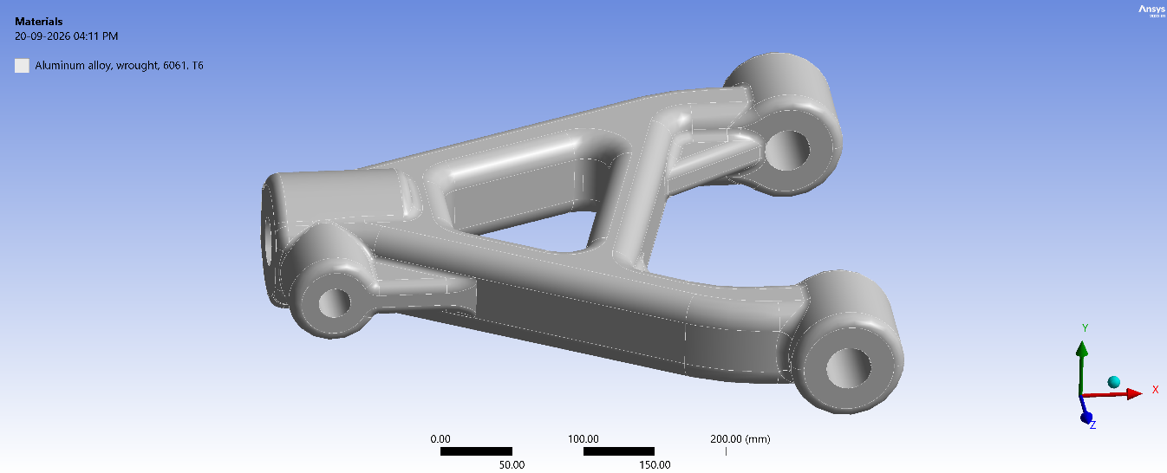
Figure 5 - Material Selection for Lower A-Arm (Control Arm)
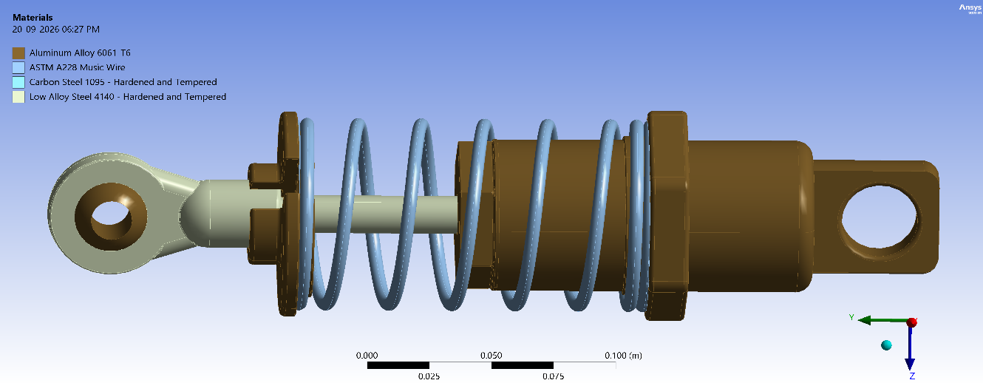
Figure 6 - Material Selection for Shock Absorber

3.3 Finite Element Discretization (Meshing)
Discretization of the continuous CAD models into finite elements was performed using ANSYS Meshing.
- An unstructured tetrahedral mesh featuring quadratic elements (higher-order elements with mid-side nodes) was generated across both components.

- Quadratic elements were explicitly chosen to handle complex curves, sharp radii, and fillet transitions effectively, ensuring accurate calculation of steep stress gradients and displacement fields.
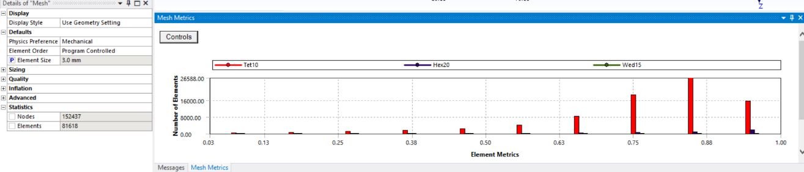
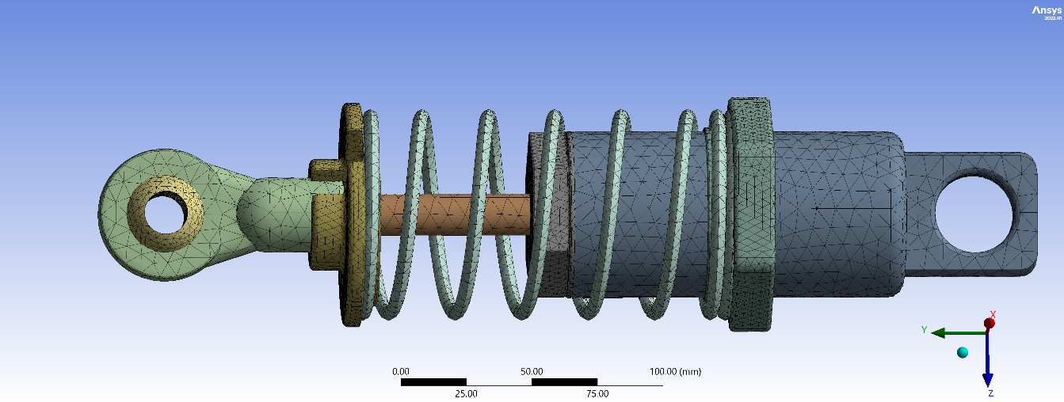
Figure 7 - Meshing Details along with Mesh Quality Metrics for Shock Absorber
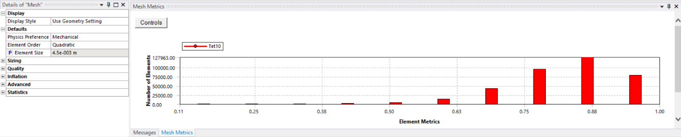
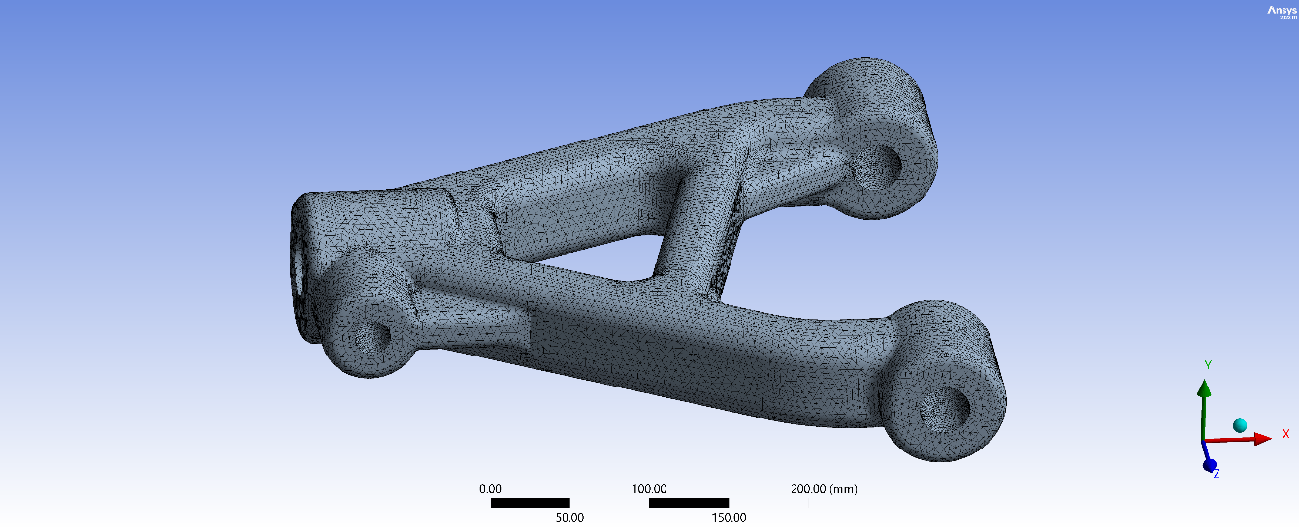
Figure 8 - Meshing Details along with Mesh Quality Metrics for Lower A-Arm

3.4 Fixed Support and Loading Conditions
To replicate real-world operating environments during severe bump, cornering, and impact scenarios, precise boundary constraints and loads were applied based on an ATV / Baja SAE vehicle mass of 250 kg to 300 kg (~2,450 N to 2,943 N total static weight). Divided across 4 wheels, the static weight resting on a single tire corner is roughly 612 N to 735 N.

- Shock Absorber Analysis Setup –
- Fixed Supports: A fixed support was applied to the bottom mounting eye for rigid attachment to the lower arm, and a cylindrical support (0 mm radial displacement) on the upper piston rod ensured smooth linear sliding while preventing lateral buckling.

- Remote Force: When the vehicle hits a severe bump, pothole, or lands from a jump, dynamic forces multiply the static corner weight (~612–735 N) by 4 times due to high g-accelerations. A 3,000 N compressive force acts as a worst-case peak impact load to test damper structural limits and spring deflection.
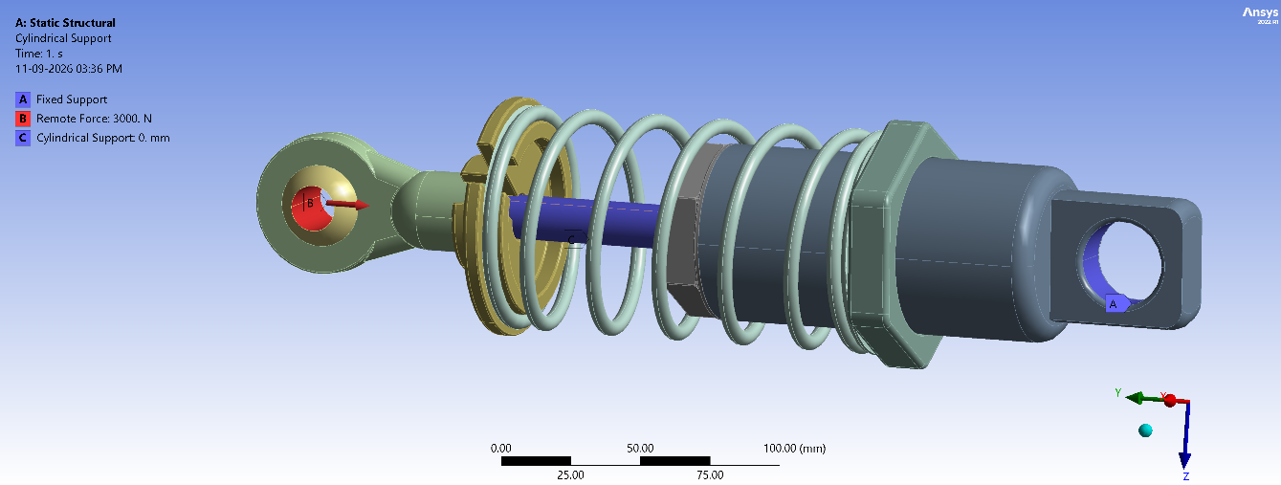
Figure 9 - Forces and Supports for Shock Absorber

- Suspension Lower A-Arm Analysis Setup –
- Fixed Supports: Fixed supports were applied to the two chassis mounting hinge holes to fully constrain the pivoting control arm ends against the vehicle frame.

- Remote Force: The The A-Arm transmits all vertical, braking, and cornering loads from the wheel to the chassis. Starting with a static corner weight of ~612–735 N, severe 4g to 5g off-road impacts multiply this force. Multiplying this dynamic load by additional safety factors for simultaneous multi-axial stresses (braking and steering) brings the design target to a rigorous 10,000 N upper-bound limit to verify structural yielding and fatigue safety.
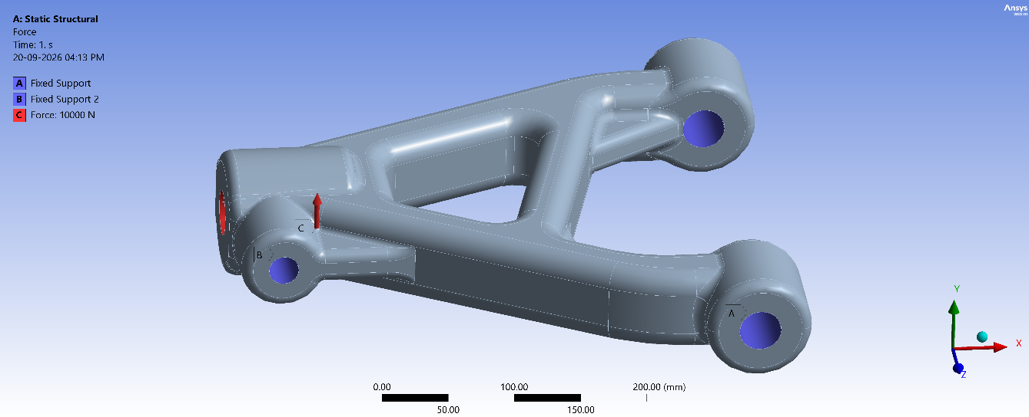
Figure 10 - Forces and Supports for Lower A-Arm

______________________________________________________

CHAPTER 4: RESULTS AND DISCUSSION
_________________________________________________________________________
This chapter presents the finite element analysis (FEA) results for the suspension system components, specifically the shock absorber assembly and the A-Arm evaluated under the peak design loads established in the methodology.

- Shock Absorber Analysis Results –
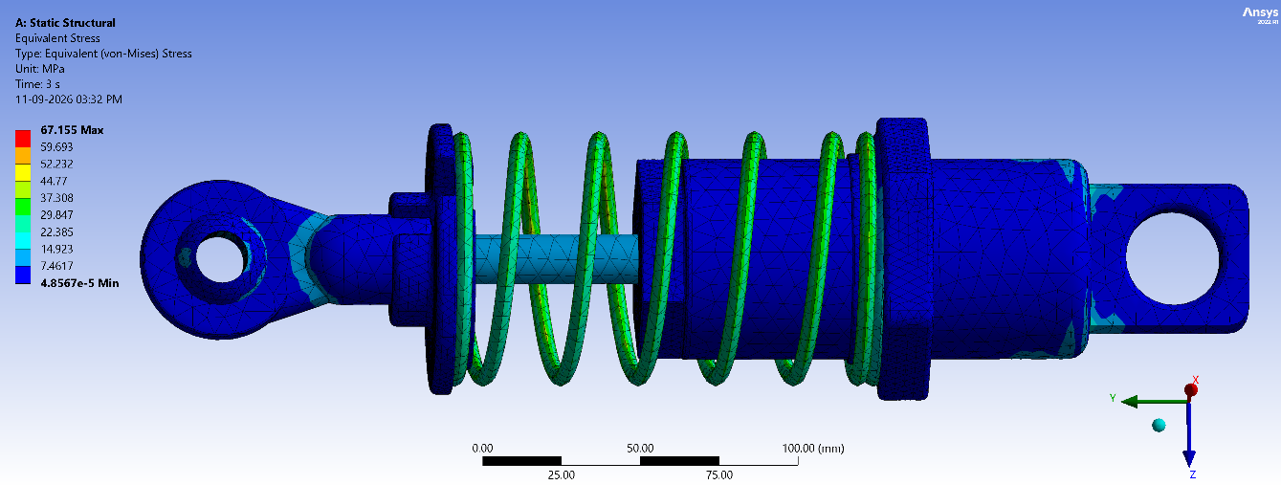
Given images summarize the finite element analysis outcomes for the suspension components evaluated under peak design loads:
Figure 11 - Equivalent Stress on Shock Absorber
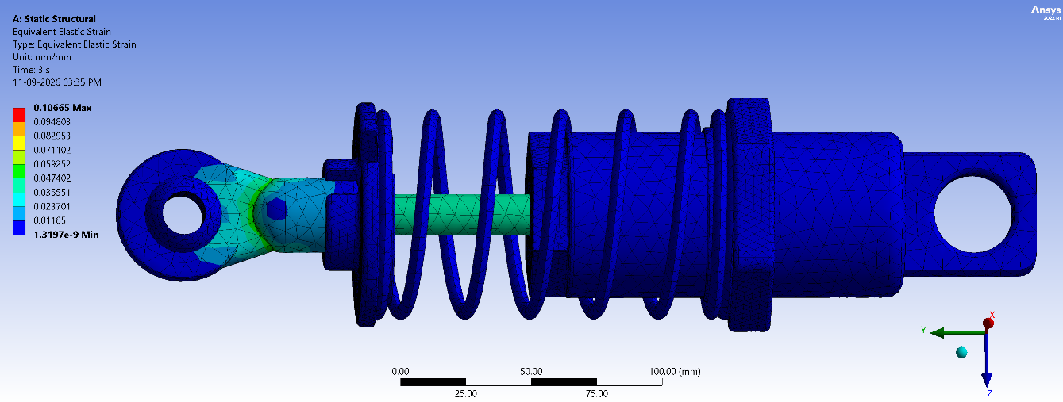
- Discussion: Shows a peak von Mises stress of 67.155 MPa localized at the upper mounting eye fillet, remaining well below the material yield limit.
Figure 12 - Equivalent Elastic Strain on Shock Absorber
- Discussion: Demonstrates maximum elastic strain 0.1066 mm/mm concentrated at the upper eye interface under compression, confirming safe elastic deformation.
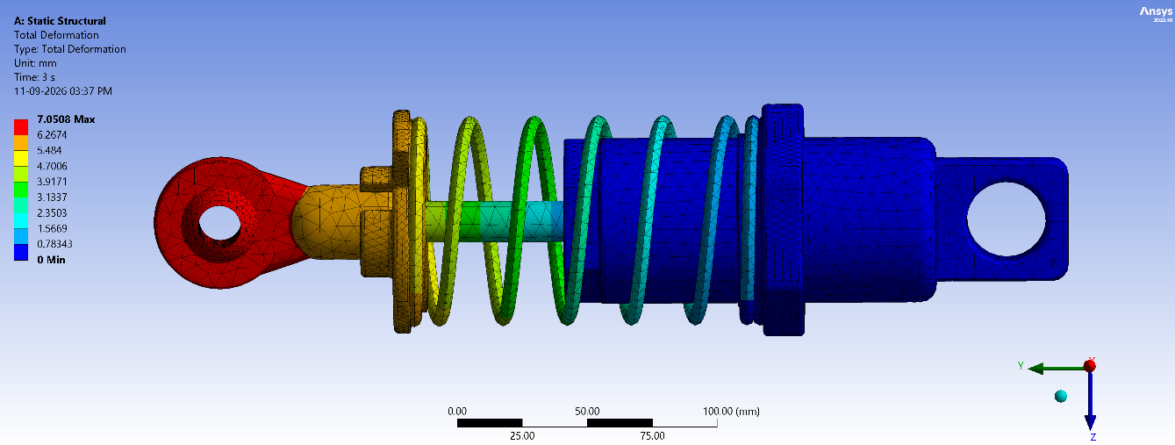
- Discussion: The maximum axial displacement peaks at 7.0508 mm near the loaded upper mounting eye, showing smooth, controlled travel under compression
Figure 13 - Total Deformation of Shock Absorber
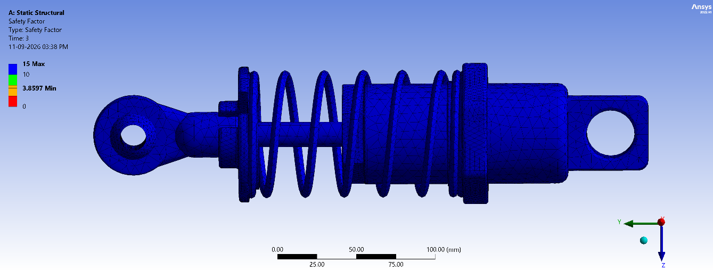
Figure 14 - Factor of Safety of Shock Absorber
- Discussion: The minimum static safety factor is 3.8597, confirming a reliable margin against structural yielding under peak loading.
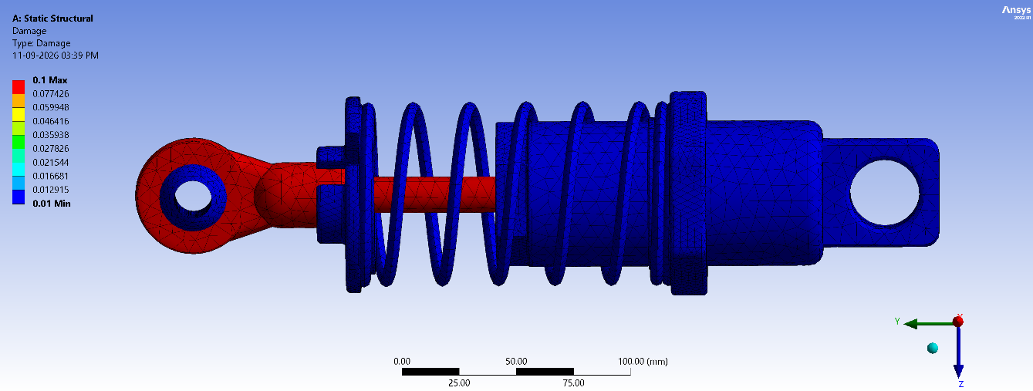
Figure 15 – Fatigue Damage to Shock Absorber
- Discussion: The cumulative fatigue damage remains very low, capped at a maximum index of 0.1, proving high resilience against repetitive off-road impact cycles.
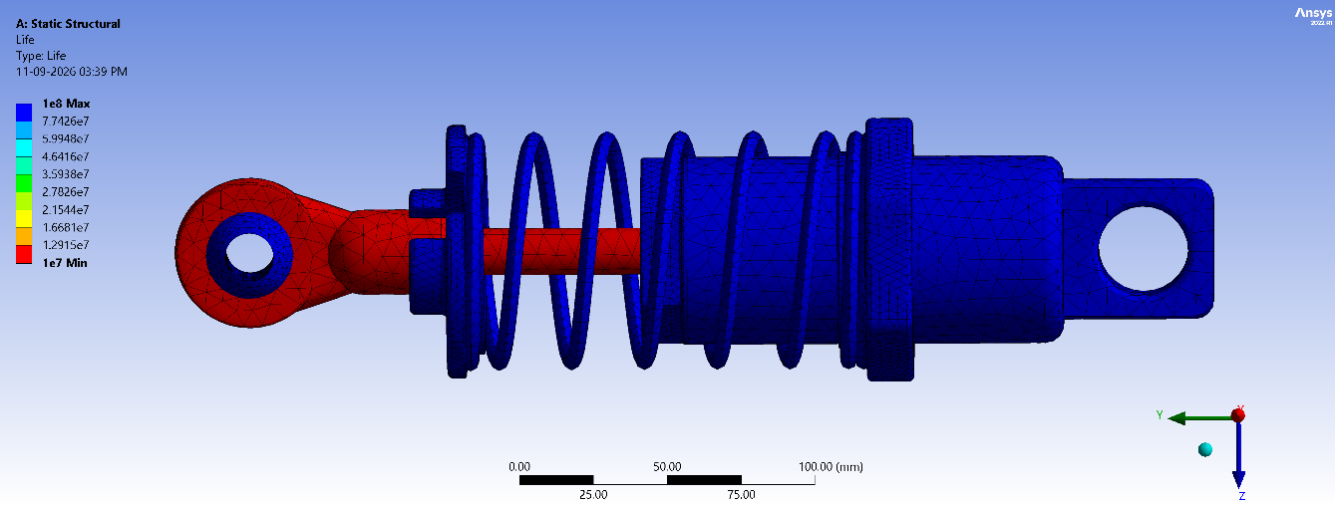
Figure 16 - Fatigue Life of Shock Absorber
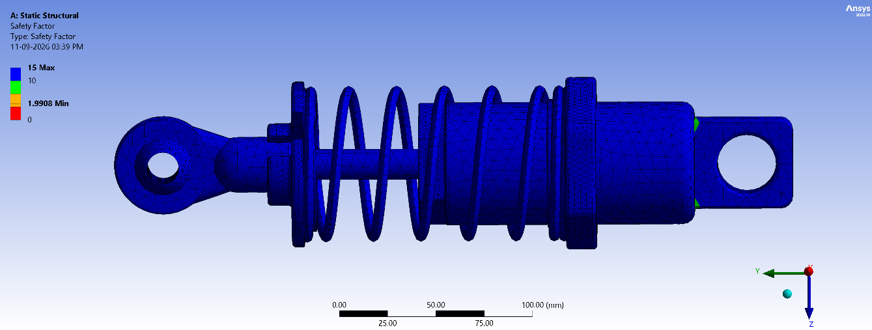
Figure 17 - Fatigue Safety Factor of Shock Absorber
- Discussion: Under cyclic loading, the minimum fatigue safety factor is 1.9908, with a predicted fatigue life exceeding $1×{10}^{7}$ cycles, ensuring long-term durability.
_________________________________________________________________________

- Lower A-Arm (Control Arm) Analysis Results –
The simulation images summarize the finite element analysis outcomes for the suspension A-Arm evaluated under the 10,000 N peak design load.

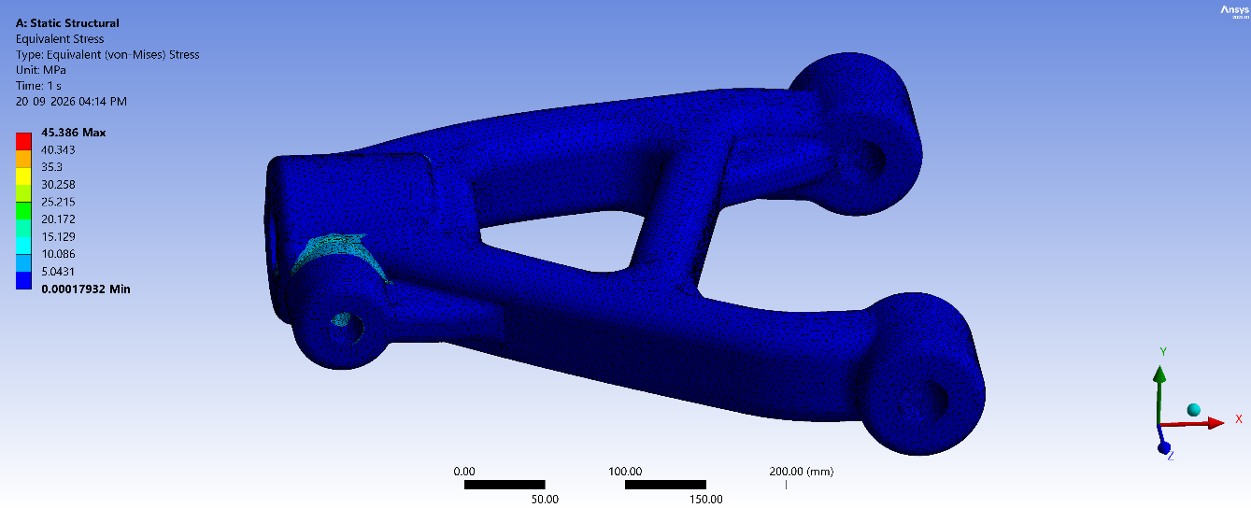
(A) Static Structural and Fatigue Analysis:
Figure 18 - Equivalent Stress on Lower A-Arm

- Discussion: The maximum equivalent stress peaks at 45.386 MPa, localized specifically around the inner hinge and neck region near support B, which remains well below the yield strength of the Al 6061-T6 material.
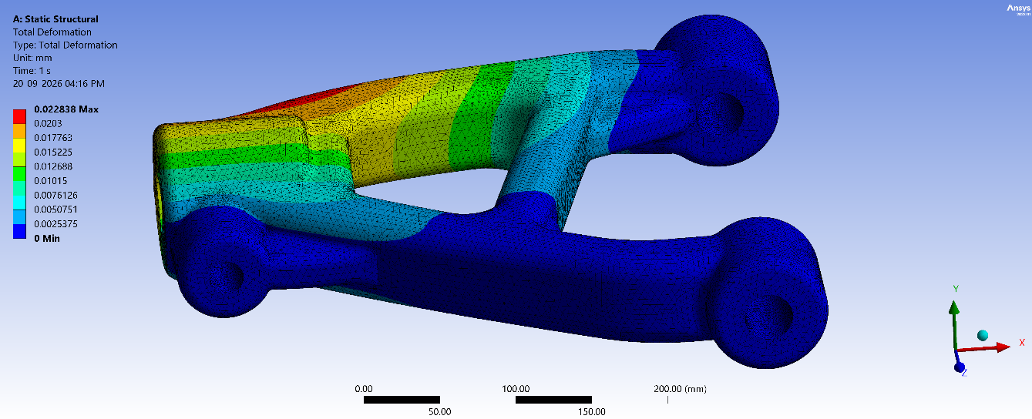
Figure 19 – Total Deformation on Lower A-Arm
- Discussion: Maximum structural displacement reaches 0.0228 mm at the outer bracket section, confirming that the A-Arm maintains exceptional geometric rigidity under peak loading without excessive flexing.

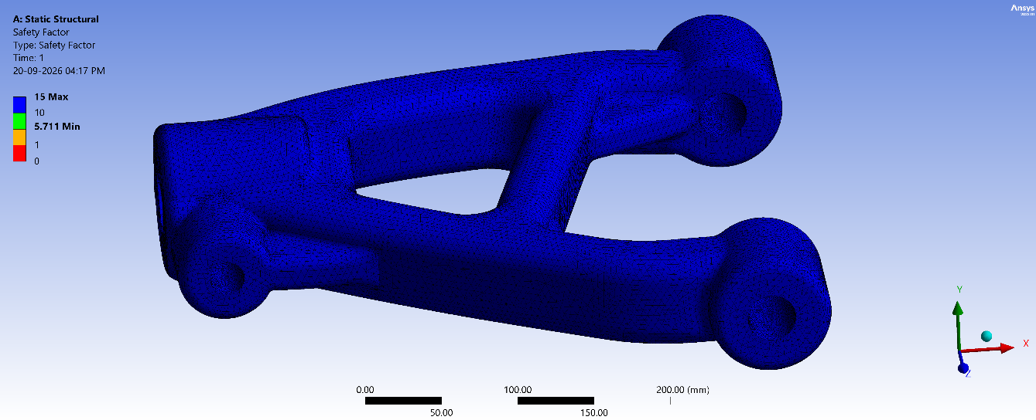
- Discussion: The minimum static factor of safety is 5.711, demonstrating a robust and reliable margin against permanent plastic yielding.
Figure 20 – Factor of Safety of Lower A-Arm
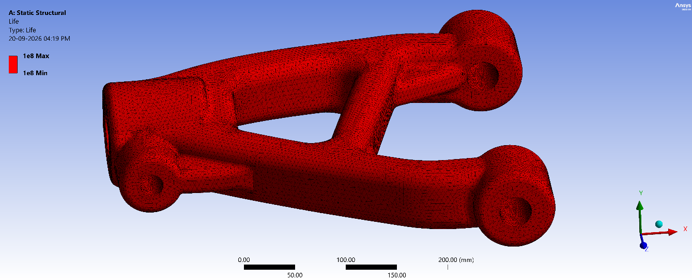
Figure 21 - Fatigue Life of Lower A-Arm
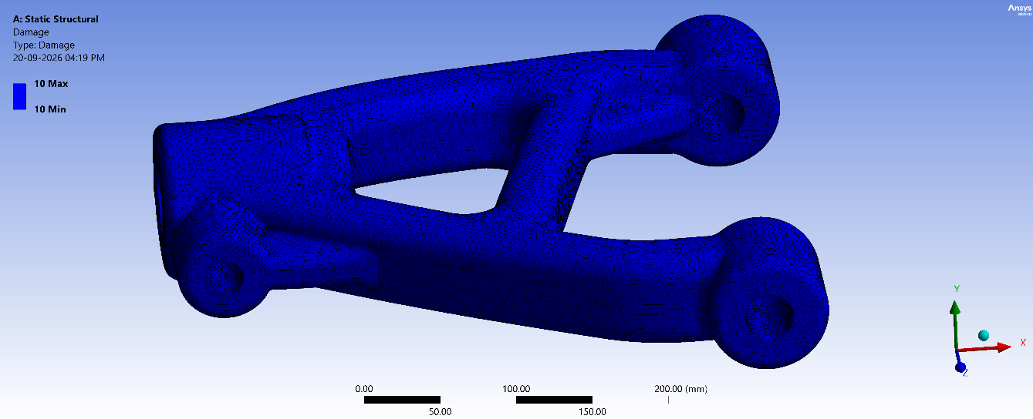
Figure 22 – Damage to Lower A-Arm

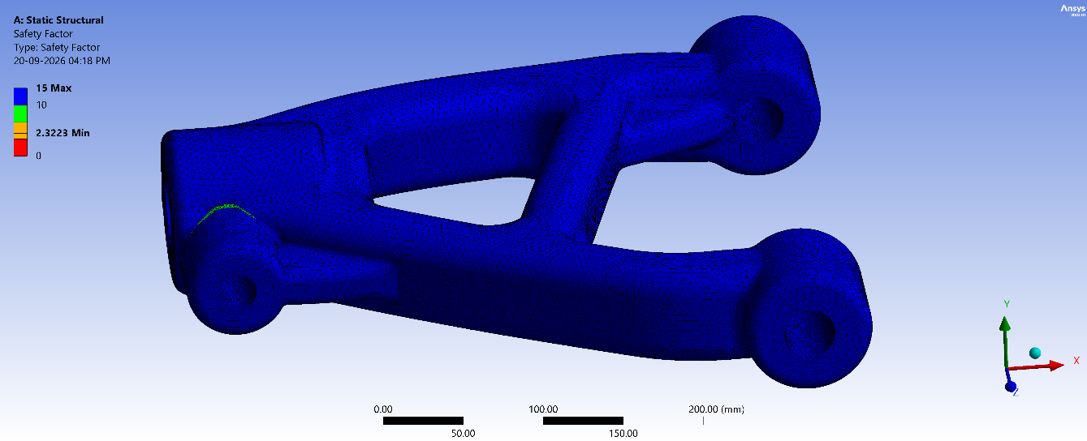
- Discussion: The predicted fatigue life consistently reaches the maximum threshold of $1×{10}^{8}$ cycles across the entire body, with a negligible cumulative fatigue damage index.
Figure 23 -Fatigue Safety Factor of Lower A-Arm

- Discussion: The minimum fatigue safety factor is 2.3223 located near the high-stress hinge transition, confirming outstanding endurance and resistance to cyclic failure under aggressive off-road track conditions.
_________________________________________________________________________

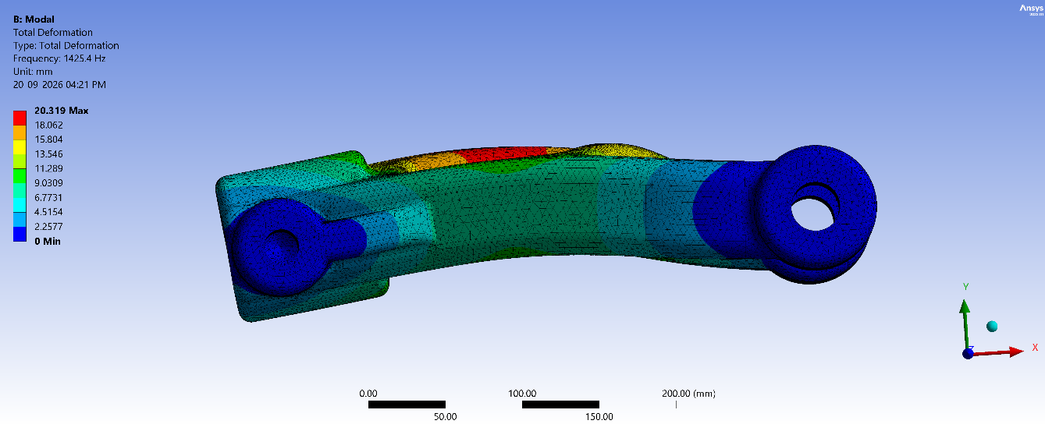
(B) Modal Analysis:
Figure 24 - Modal Shape 1 (Total Deformation 1)

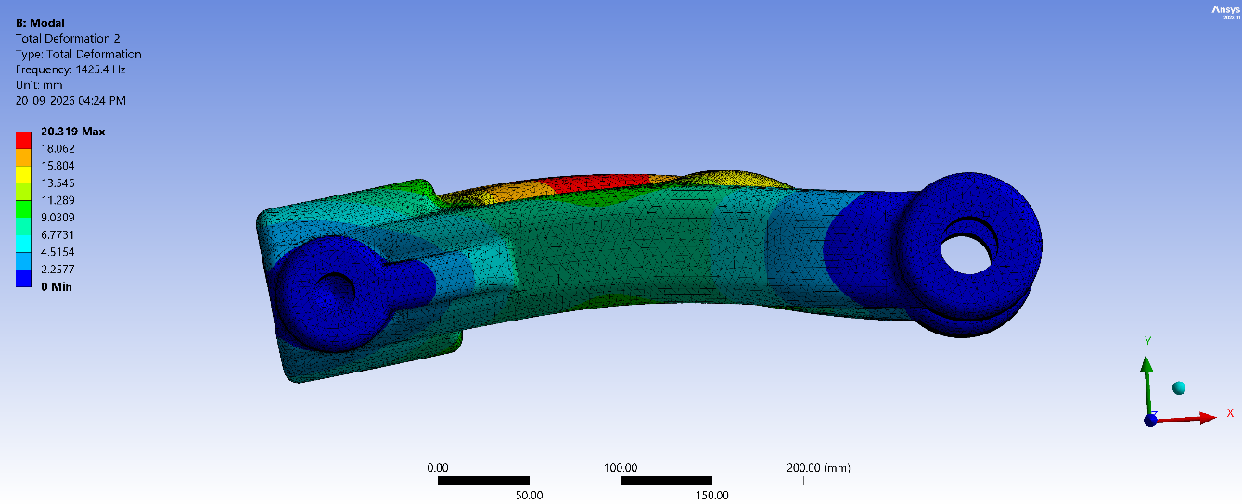
- Discussion: Exhibits a fundamental bending mode at a frequency of 1,425.4 Hz with a maximum relative deformation of 20.319 mm concentrated along the central arm span.

Figure 25 - Modal Shape 2 (Total Deformation 2)
- Discussion: Illustrates a secondary harmonic response at 1,425.4 Hz showing identical peak relative displacement patterns (20.319 mm) across the main structural body.
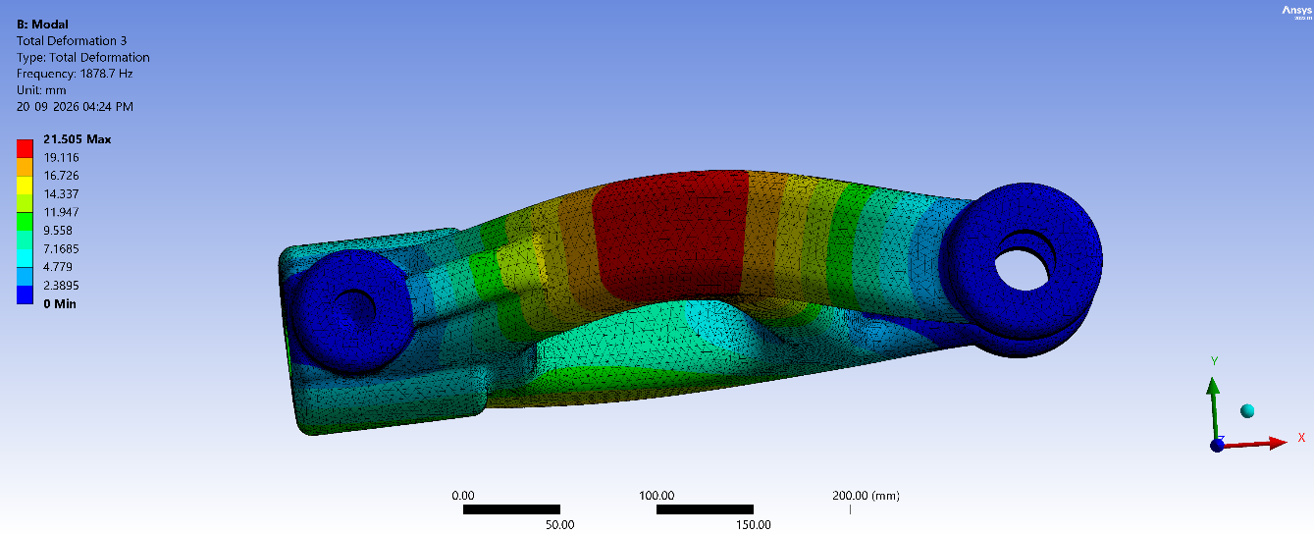
Figure 26 - Modal Shape 3 (Total Deformation 3)
- Discussion: Illustrates a secondary harmonic response at 1,425.4 Hz showing identical peak relative displacement patterns (20.319 mm) across the main structural body.

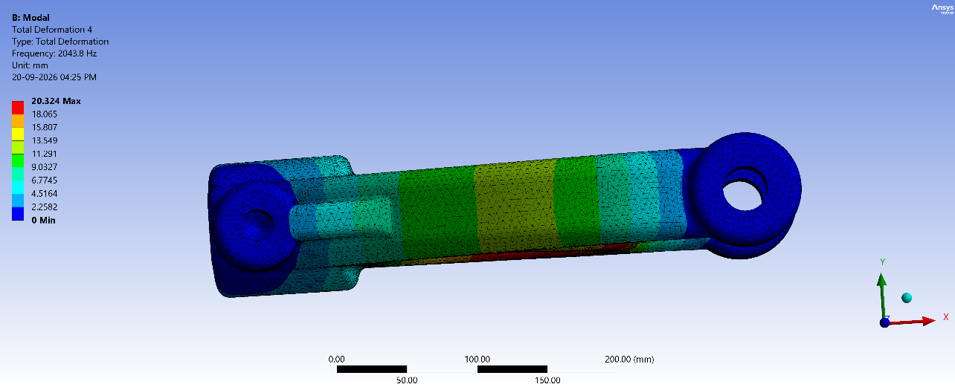
- Discussion: Records a lateral oscillation mode at 2,043.8 Hz reaching a peak relative displacement of 20.324 mm along the middle shaft segment.
Figure 27 - Modal Shape 4 (Total Deformation 4)

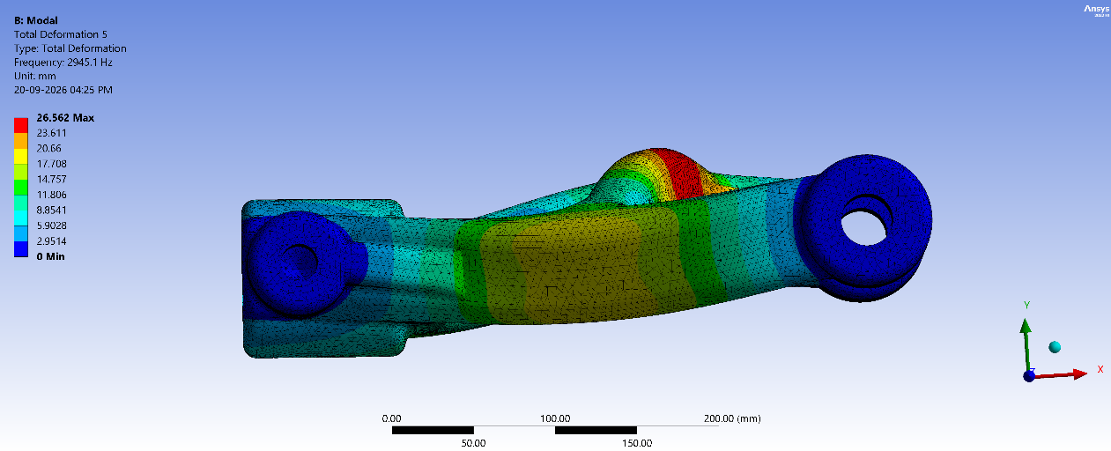
- Discussion: Captures a higher-order out-of-plane bending mode at 2,945.1 Hz with maximum relative deformation increasing to 26.562 mm at the upper curved spine.
Figure 28 - Modal Shape 5 (Total Deformation 5)

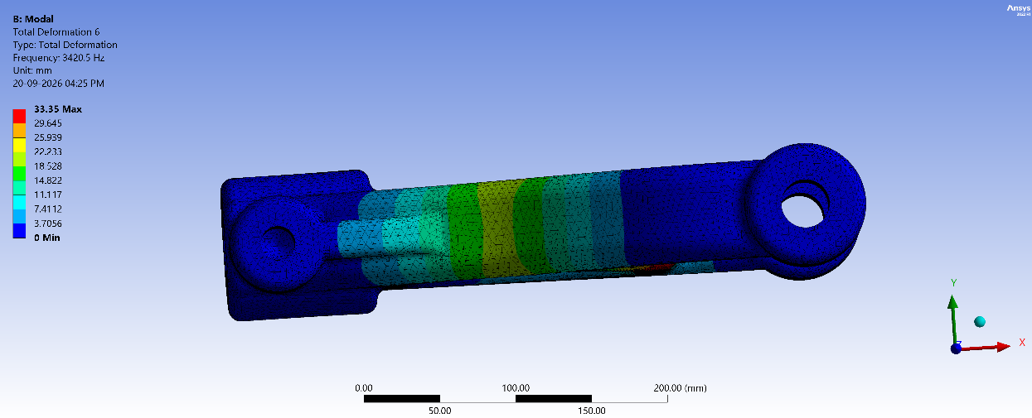

Figure 29 - Modal Shape 6 (Total Deformation 6)
- Discussion: Shows a complex transverse vibration mode at 3,420.5 Hz peaking at 33.35 mm of relative displacement along the central arm profile.
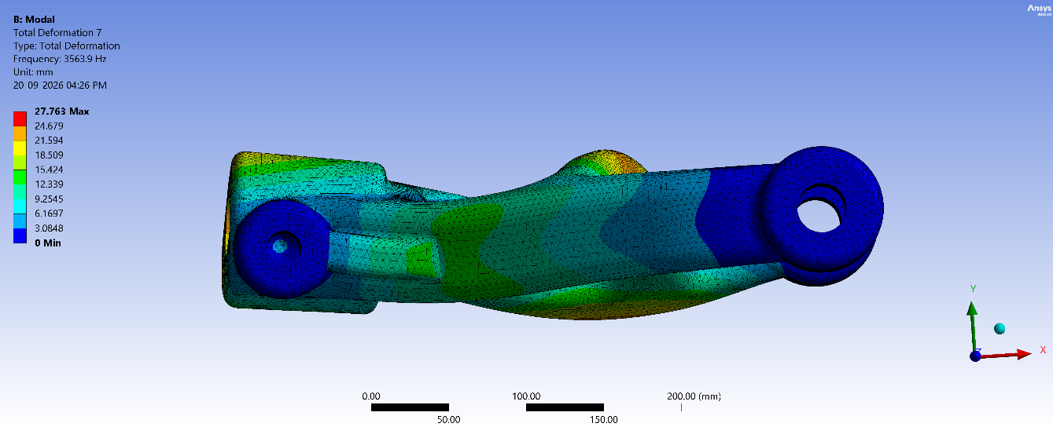
Figure 30 - Modal Shape 7 (Total Deformation 7)

- Discussion: Demonstrates a high-frequency multi-node modal response at 3,563.9 Hz with a maximum relative deformation of 27.763 mm, confirming that natural frequencies occur well above normal off-road operational input spectrums to prevent destructive resonance.

______________________________________________________

CHAPTER 5: CONCLUSION
_________________________________________________________________________

5.1. Conclusions
The objective of this term project was to design and validate the structural integrity of the suspension system components (A-Arm and Shock Absorber) for a 250–300 kg Baja SAE/ATV vehicle under extreme off-road operating conditions.

Some of the conclusions drawn from this study include –

- Rigorous Load Justification: Static corner weights (~612–735 N) were successfully scaled through $4g\text{-}5g$ dynamic multipliers to establish reliable upper-bound design limits of 10,000 N for the A-Arm and 3,000 N for the shock absorber.
- Structural Safety and Yield Limits: Finite element analysis confirmed that all maximum von Mises stresses remain safely below the material yield strengths (reaching 45.386 MPa for the Al 6061-T6 A-Arm and 67.155 MPa for the shock assembly), ensuring all components operate completely within safe elastic limits without permanent deformation.
- Fatigue Endurance and Deformation: The selected materials and geometric configurations demonstrated robust static safety factors (5.711 for the A-Arm and 3.8597 for the damper) alongside high cyclic fatigue lives (exceeding $1×{10}^{7}$ to $1×{10}^{8}$ cycles), proving that the design easily withstands aggressive off-road racing environments without structural failure.

5.2. Future work
In off-road vehicle suspension design and finite element analysis, individual components are studied under specific idealized load cases. Since vehicle dynamics continuously evolve with new lightweight alloy compositions and alternative composite materials being developed, there is always a need for refined multi-axial fatigue studies. Optimization studies are also required to find the most optimum mass-to-strength operating parameter values for different structural geometries and required safety margins.
Several other studies can be conducted by expanding FEA validation to transient multi-wheel simultaneous impact scenarios, thermal effects from high-speed damper cycling, studies on maximizing component life through topology optimization, and the integration of composite or hybrid materials. And since standard structural layouts still encounter severe stress concentrations under unpredictable terrain impacts, further studies can be conducted on how to optimize joint bushings and mounting interfaces to make structural designs even more resilient for such extreme applications.
_________________________________________________________________________

REFERENCES
- J. E. Shigley, C. R. Mischke, and R. G. Budynas, Mechanical Engineering Design, 7th ed., New York: McGraw-Hill, 2004.J. E. Shigley and C. R. Mischke, Mechanical Engineering Design, 6thed., New York: McGraw-Hill, 2001.
- ANSYS Inc., ANSYS Mechanical User's Guide: Structural Analyses Guide, Release 2025.
- Complete Automobile Suspension System Components, Solidworks Youtube Tutorials
- Ansys Workbench Youtube Tutorials (Static Structural and Modal Analysis)
- Society of Automotive Engineers (SAE), Baja SAE Rulebook 2027.

